Digital manufacturing is a comprehensive approach to manufacturing that leverages digital technologies and information throughout the entire product lifecycle, from design and prototyping to production and maintenance. The goal is to enhance efficiency, reduce costs, and improve the overall quality of manufacturing processes. Here's an overview of the concept, methodology, and procedure of digital manufacturing:

Concept of Digital Manufacturing:
Digital manufacturing is rooted in the integration of digital technologies into all aspects of the manufacturing process. It involves the use of digital data and models to drive various activities, allowing for more accurate, agile, and efficient production. Key elements of the concept include:

Digital Twin: A digital twin is a virtual representation of a physical product or system. It includes both the product's geometry (3D model) and non-geometric data (such as material properties, behavior, and operational data). The digital twin enables real-time monitoring and analysis throughout the product's lifecycle.

Simulation and Modeling: Digital manufacturing relies heavily on simulation and modeling tools. These tools help predict and optimize the performance of manufacturing processes, product designs, and even supply chain logistics. By simulating different scenarios, manufacturers can identify potential issues and optimize their processes before physical implementation.

Data Integration: Digital manufacturing emphasizes the seamless integration of data across various stages of the product lifecycle. This includes design data, production data, and operational data. Integrating data allows for a more holistic view of the entire manufacturing process, enabling informed decision-making.

Methodology of Digital Manufacturing:
The methodology of digital manufacturing involves several key steps and principles:

Digital Design and Prototyping: The process begins with digital design using Computer-Aided Design (CAD) tools. Digital prototypes are created and tested virtually, reducing the need for physical prototypes and iterations.

Simulation and Analysis: Simulation tools are used to analyze and optimize various aspects of the manufacturing process, such as production flow, resource utilization, and product performance. This helps in identifying potential issues and improving efficiency.

Data Management: Effective data management is crucial for digital manufacturing. This involves organizing and integrating data from various sources, ensuring consistency and accuracy throughout the product lifecycle.

Collaboration and Communication: Digital manufacturing promotes collaboration among different stakeholders, including designers, engineers, and production teams. Communication is facilitated through digital platforms to ensure that everyone is working with the latest information.

Procedure of Digital Manufacturing:
The procedure of digital manufacturing involves specific steps:

Digital Design: Begin with creating a digital model of the product using CAD tools. This model serves as the basis for the entire manufacturing process.

Simulation and Analysis: Use simulation tools to analyse the digital model for various factors such as stress, heat distribution, and manufacturing feasibility.

Prototyping: Create a digital prototype to further test and refine the design. This step may involve rapid prototyping techniques or virtual testing.

Production Planning: Utilize digital tools for production planning, including process optimization, resource allocation, and scheduling.

Real-time Monitoring: Implement sensors and IoT devices for real-time monitoring of manufacturing processes. This data feeds back into the digital model, allowing for continuous improvement.

Quality Control: Implement digital tools for quality control throughout the production process, ensuring that the final product meets the required standards.

Lifecycle Management: Manage the entire product lifecycle, from design and production to maintenance and disposal, using digital tools to optimize each stage.

Digital manufacturing, with its emphasis on data-driven decision-making and integration of digital technologies, contributes to more efficient and agile manufacturing processes, ultimately leading to improved product quality and reduced time-to-market.

Stereolithography (SLA) is a 3D printing or additive manufacturing technology that is commonly used for producing prototypes, models, and parts with high precision and intricate geometries. It was the first 3D printing technology developed and commercialized, introduced by Chuck Hull in the 1980s.

Here's an explanation of the key concepts and the process of stereolithography:

Principle:

Stereolithography operates on the principle of photopolymerization. It involves the use of a liquid photopolymer resin that solidifies when exposed to ultraviolet (UV) light. The process builds objects layer by layer, with each layer being cured and solidified before the next one is added.
Process:

Preparation of 3D Model: The process begins with the creation of a 3D computer-aided design (CAD) model of the object to be printed. This digital model is sliced into thin cross-sectional layers, typically ranging from 0.05 to 0.15 millimeters.

Photopolymer Resin: A vat of liquid photopolymer resin is used as the printing material. The resin is typically clear or translucent.

Layer-by-Layer Printing: The 3D printing machine, known as a stereolithography apparatus (SLA) or 3D printer, consists of a platform that can be lowered into the liquid resin. A UV laser is directed by mirrors or galvanometers to trace and solidify the pattern of each layer on the surface of the liquid resin.

Platform Movement: After each layer is cured, the platform is incrementally lowered, allowing the next layer of resin to flow over the solidified layer. The process is repeated until the entire object is built up layer by layer.

Post-Processing: Once the printing is complete, the object is typically removed from the liquid resin. Depending on the specific SLA system and the design of the object, post-processing steps such as cleaning, support removal, and curing may be required to finalize the part.

Applications:

Stereolithography is widely used for rapid prototyping and the production of high-quality, detailed models. It is particularly suitable for creating prototypes in the fields of product development, engineering, and design.
SLA technology is capable of producing intricate and finely detailed parts, making it valuable for applications where precision and surface finish are critical.
The technology is also used for producing investment casting patterns, dental models, and other applications where a high level of detail is required.
Advantages:

High precision and fine details: SLA is known for its ability to produce highly detailed and accurate parts with smooth surface finishes.
Versatility: It can accommodate a wide range of geometries and complex shapes.
Speed: SLA can be relatively fast, especially for smaller parts.
Limitations:

Material limitations: The range of available photopolymer resins may be more limited compared to other 3D printing technologies.
Post-processing: Some SLA parts may require post-curing or additional cleaning steps.
Stereolithography has paved the way for various 3D printing technologies and remains a valuable tool in the rapid prototyping and additive manufacturing landscape.

Conversion of 3D model to STL file
Stereolithography (SLA) is a 3D printing or additive manufacturing technology that is commonly used for producing prototypes, models, and parts with high precision and intricate geometries. It was the first 3D printing technology developed and commercialized, introduced by Chuck Hull in the 1980s.

Here's an explanation of the key concepts and the process of stereolithography:

Principle:

Stereolithography operates on the principle of photopolymerization. It involves the use of a liquid photopolymer resin that solidifies when exposed to ultraviolet (UV) light. The process builds objects layer by layer, with each layer being cured and solidified before the next one is added.

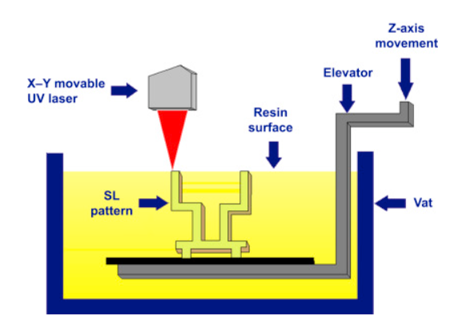

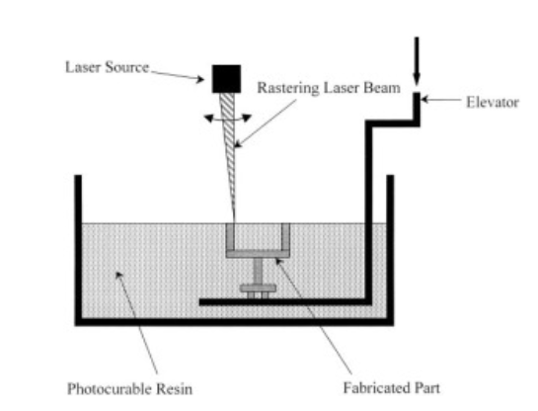
Figure 1Typical SLA Apparatus

Process:
Preparation of 3D Model: The process begins with the creation of a 3D computer-aided design (CAD) model of the object to be printed. This digital model is sliced into thin cross-sectional layers, typically ranging from 0.05 to 0.15 millimeters.
Photopolymer Resin: A vat of liquid photopolymer resin is used as the printing material. The resin is typically clear or translucent.
Layer-by-Layer Printing: The 3D printing machine, known as a stereolithography apparatus (SLA) or 3D printer, consists of a platform that can be lowered into the liquid resin. A UV laser is directed by mirrors or galvanometers to trace and solidify the pattern of each layer on the surface of the liquid resin.
Platform Movement: After each layer is cured, the platform is incrementally lowered, allowing the next layer of resin to flow over the solidified layer. The process is repeated until the entire object is built up layer by layer.
Post-Processing: Once the printing is complete, the object is typically removed from the liquid resin. Depending on the specific SLA system and the design of the object, post-processing steps such as cleaning, support removal, and curing may be required to finalize the part.
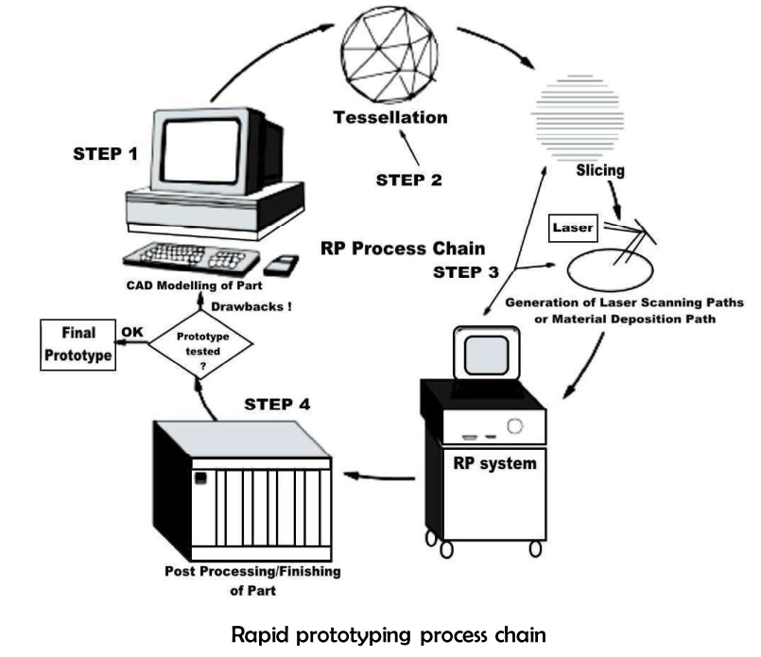

Applications:
Stereolithography is widely used for rapid prototyping and the production of high-quality, detailed models. It is particularly suitable for creating prototypes in the fields of product development, engineering, and design.
SLA technology can produce intricate and finely detailed parts, making it valuable for applications where precision and surface finish are critical.
The technology is also used for producing investment casting patterns, dental models, and other applications where a high level of detail is required.
Advantages:
High precision and fine details: SLA is known for its ability to produce highly detailed and accurate parts with smooth surface finishes.
Versatility: It can accommodate a wide range of geometries and complex shapes.
Speed: SLA can be relatively fast, especially for smaller parts.

Limitations:
Material limitations: The range of available photopolymer resins may be more limited compared to other 3D printing technologies.
Post-processing: Some SLA parts may require post-curing or additional cleaning steps.
Stereolithography has paved the way for various 3D printing technologies and remains a valuable tool in the rapid prototyping and additive manufacturing landscape.

